1-

Student (snum: integer, sname: string, major: string, level: string,age: integer)  
Class (name: string, meets at: string, room: string, d: integer)  
Enrolled (snum: integer, cname: string)  
Faculty (fid: integer, fname: string, deptid: integer)

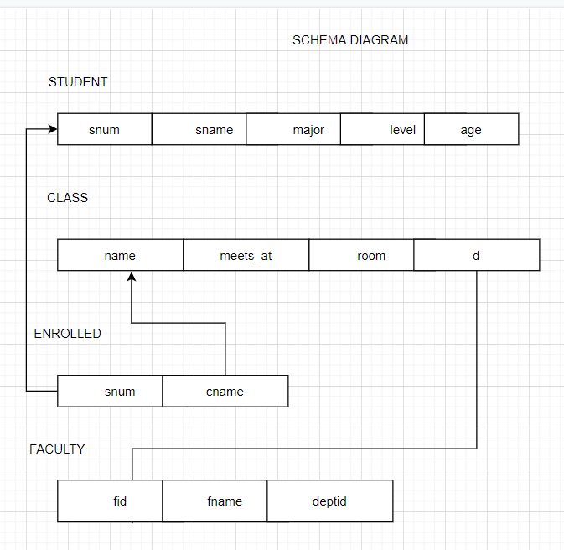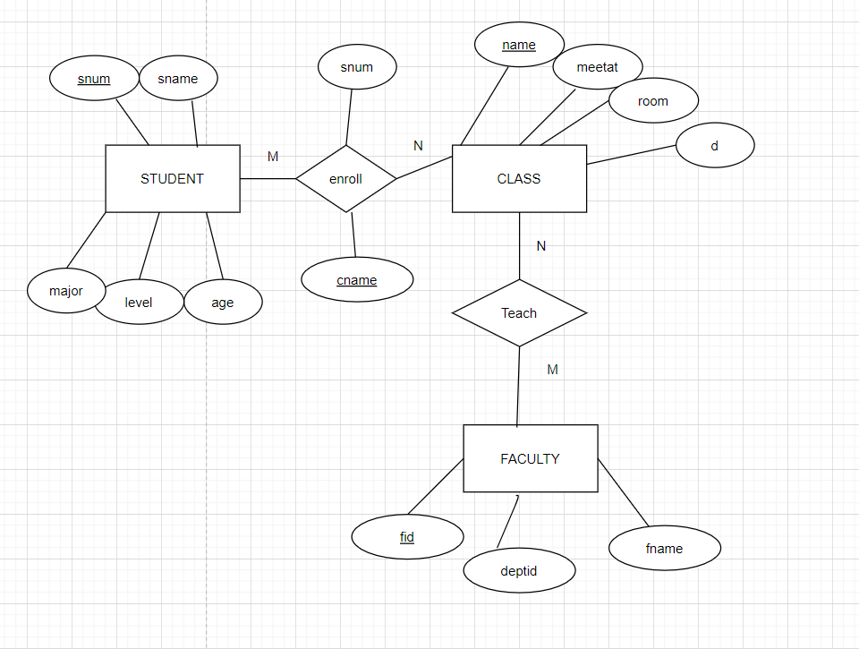

2-

BRANCH(branch-name:string,branch-city:string,assets:real)  
ACCOUNT(accno:int,branch-name:string,balance:real)  
DEPOSITOR(customer-name:string,accno:int)  
CUSTOMER(customer-name:string,customer-street:string,city:string)

